Lab 3 - Tableau
Name: eamonn kelly
Student number = D24127620
Email address = D24127620@myTUDublin.ie
Date = 5th Oct 2026

The following is my submission for Lab 3 – Tableau

Q1. What years did the museum acquire (buy or via donations) the most art?

Answer:

Tableau link =
https://public.tableau.com/app/profile/eamonn.kelly1417/viz/Lab3-Q1-NumberofArtAquisitionsperYear-Top5HighlightedinYellow/Q1-ArtObjectsAquiredperYear?publish=yes

Screenshot:

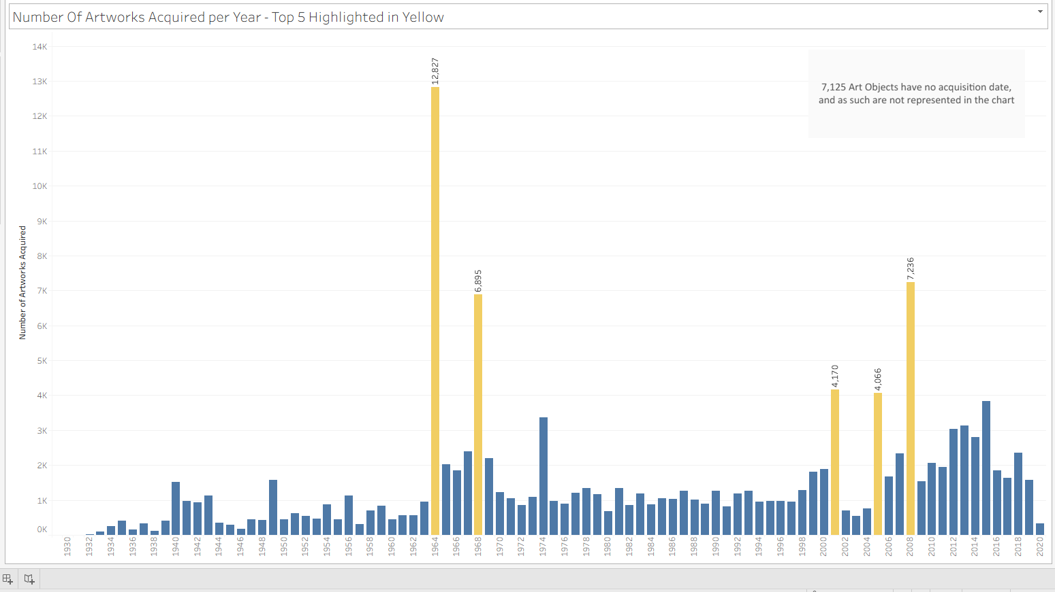

- We used “Date Acquired” field to account for when an art work was acquired regardless of how the acquisition took place.

Q2. Can you identify why there was such an increase in art pieces acquired during these years?

Answer
A significant increase in bequests and gifts in those years accounted for the increase in art object acquisition.

Tableau link =
https://public.tableau.com/app/profile/eamonn.kelly1417/viz/Lab3-Q2-NumberofArtAquisitionsperYearHowtheywereAcquired/Q2-howacquired?publish=yes

Screenshot:

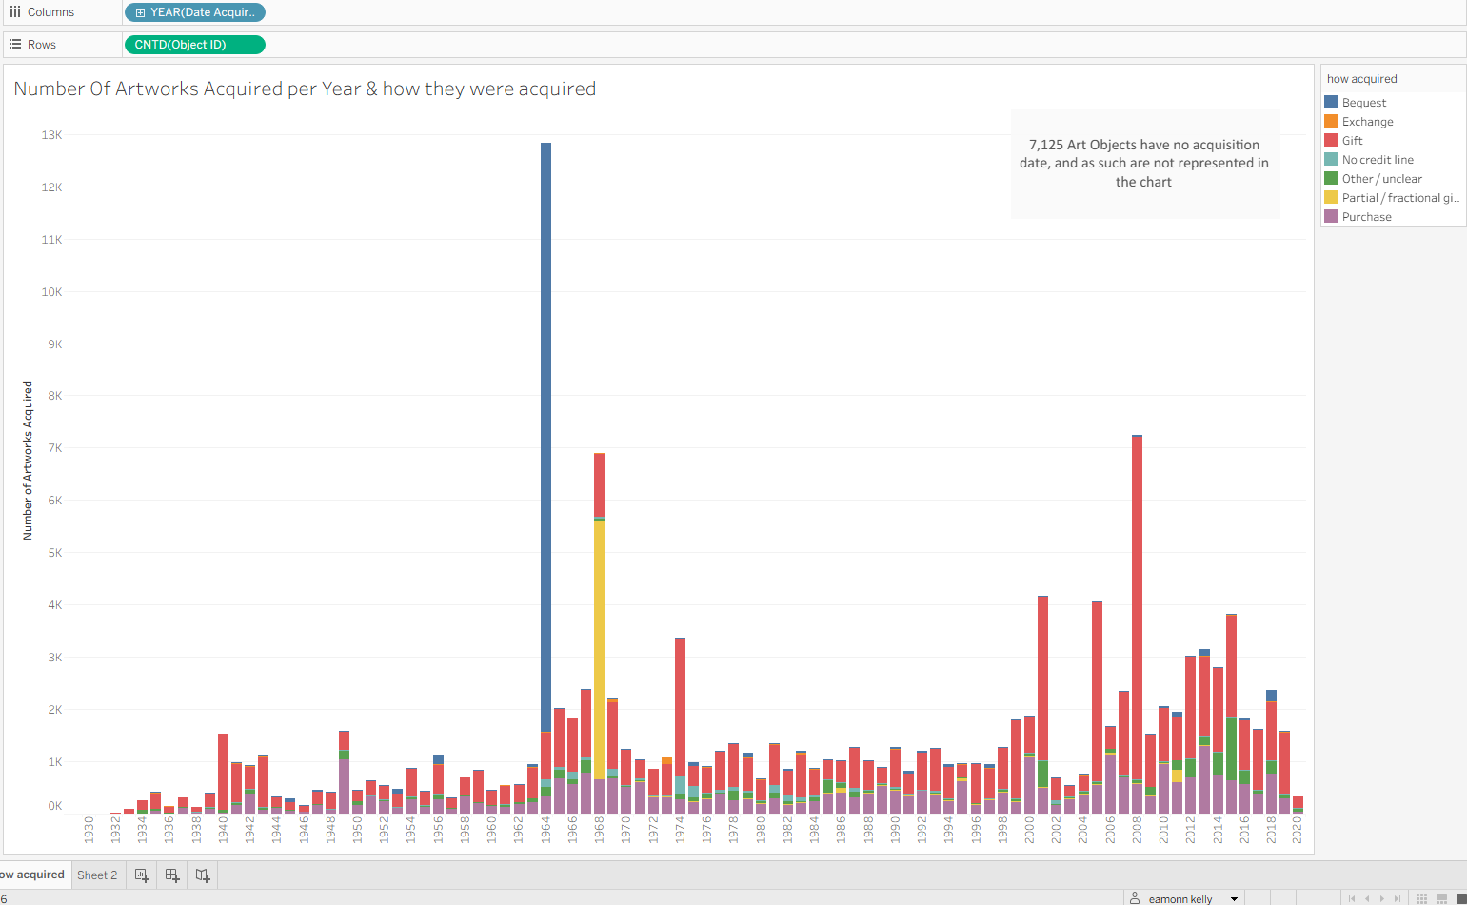

- The increase in the years where there as a significant increase in number of artworks acquired can be accounted for by a significant increase in bequests and gifts in those years.

Q3. What department has the most artwork?

Answer
The Drawings & Prints Department has the most Artworks.

Tableau link =

https://public.tableau.com/app/profile/eamonn.kelly1417/viz/Lab3-Q3-NumberofArtworksperDept-DrawingsPrintsDepthasthemostArtworks/Q3-NumberofArtworksperDept?publish=yes

Screenshot:
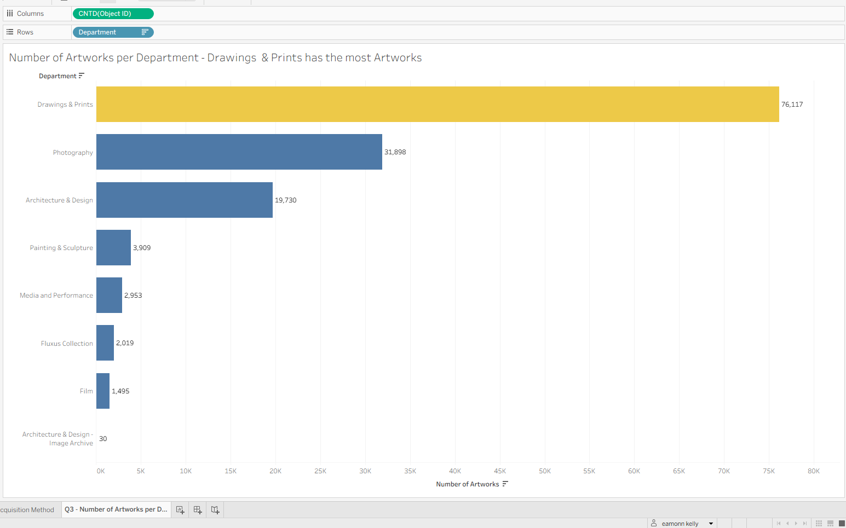

Q4. What is the split between catalogued art works and non-catalogued?

Answer
63% of Artworks are catalogued and 36% are not.

Tableau link =
https://public.tableau.com/app/profile/eamonn.kelly1417/viz/Lab3-Q4-CataloguedandNon-cataloguedsplit/Q4-CataloguedandNon-Catalogued?publish=yes

Screenshot:

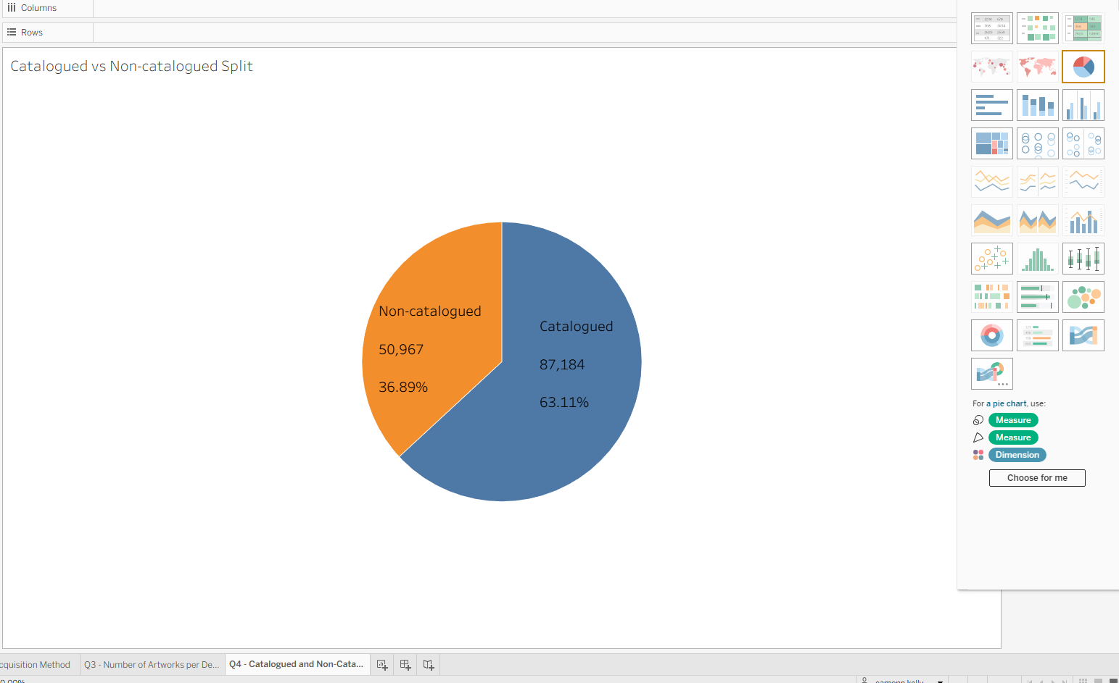

Q5. In what year did the museum acquire the highest number of art pieces for the film department?

Answer
- 2012 had the most Film dept acquisition with 149 artworks being acquired.

Tableau link =
https://public.tableau.com/app/profile/eamonn.kelly1417/viz/Lab3-Q5-FilmDeptAcquisitionsperyr/Q5-FilmDeptAcquisitionspyr?publish=yes

Screenshot:
